A PROJECT REPORT ON

LAMINAR NATURAL CONVECTION IN INCLINED ENCLOSURES BOUNDED BY A SOLID WALL

**FOR**

Course CL CFD 613

Of Academic Year 2020-2021

**Submitted By**

Rahul Meel

( 170103051)

Shivashish Biswal

( 170103063)

Ila Kulkarni

(20435100 )

Mahesh Mahajan

(204351007)

**Guide**

Prof. Anandlakshmi



**Indian Institute of Technology, Guwahati.**

**NOV-2020**

CONTENTS

LIST OF SYMBOLS 3

1. INTRODUCTION 5

2. PROBLEM STATEMENT 5

3. MATHEMATICAL MODELING 6

Assumption 6

Boussinesq Approximation 6

Governing Equations 6

Boundary Conditions 7

4. Numerical method 7

Staggered Grid 7

SIMPLE (Semi Implicit Method for Pressure Linked Equations) Algorithm 8

5. RESULTS AND DISCUSSION 10

To study the effect of inclination 10

To study the effect of Rayleigh number 12

To study the effect of conductivity 13

6. MATLAB CODE 14

# LIST OF SYMBOLS

A Aspect ratio, H/L

g Acceleration due to gravity, m/s2,

·

k Thermal conductivity, W/m.K

·

L Cavity width, m

Nu Nusselt number

p Dimensionless pressure,

q Heat flux, W/m2

Ra Rayleigh number,

T Temperature, K

u, v Dimensional velocity in x and y direction

w Bounding wall thickness, m

W Dimensionless bounding wall thickness, W / L

Pr Prandtl number

x, y Cartesian coordinates

t Time, s

h Convection coefficient

H Cavity height

Greek symbols

α Thermal diffusivity, m2/s

β Coefficient of thermal expansion of fluid, 1/K

θ Dimensionless temperature

·

µ Dynamic viscosity, kg/m.s

ρ Fluid density, kg/m3

τ General viscous diffusion coefficient

φ Angle of inclination, degree

ν Kinematic viscosity, m2/s

Superscripts

’ Dimensional variables average

Subscripts

c Cold wall

ƒ Fluid properties

# LIST OF FIGURES

Fig. 1 Problem geometry and boundary conditions 5

Fig. 2 Staggered and main Grid in X direction 8

Fig. 3 Staggered Grid in 2 Dimensions 8

Fig. 4 Flowchart of SIMPLE algorithm 9

Fig. 5 Standard Grid Notations 9

Fig. 6 Variation of Streamlines and Isotherm with 10^6 Rayleigh number and at 30-degree angle of inclination 11

Fig. 7 Variation of Streamlines and Isotherm with 10^6 Rayleigh number and at 90-degree angle of inclination 11

Fig. 8 Variation of Streamlines and Isotherms with 10^6 Rayleigh number and at 120-degree angle of inclination 11

Fig. 9 Variation of Streamlines and Isotherms with 1000 Rayleigh number at 90 degree 12

Fig. 10 Variation of Streamlines and Isotherms with 100000 Rayleigh number at 90 degree 12

Fig. 11 Variation of Streamlines and Isotherms with 1000000 Rayleigh number at 90 degree 13

Fig. 12 Variation in isotherms with the conductivity ratio 1 at Ra=100000 13

Fig. 13 Variation in the isotherms with conductivity ratio 10 at Ra=100000 13

# 1. INTRODUCTION

Natural convection is phenomena where any fluid motion occurs by natural means such as buoyancy. The difference in buoyancy may occur due to some temperature gradient which in terms leads to a force which makes motion possible within the fluid. In day to day life we encounter many problems where the natural convection plays a vital role. When we take bathe from a solar thermal system we are using the natural convection phenomena, monsoon is due to natural convection. Many examples are there which makes us believe how much this phenomenon is important, even in industries. The natural convection is studied extensively with the use of computational power and is helping to implement the real data with much closer approximation .Much study is being done in rectangular inclined enclosure which is being used in many real industrial applications considering ,heat flux is constant. The inclined enclosure can be used following applications,

* Building air conditioning system ,
* Solar collector technology
* Nuclear reactor technology

Many examples can be given. Any engineering projects aims to achieve the goal of optimizing the parameters, to design the economically viable optimized system; same applies to our project as well. To solve the problem of natural convection we utilize the equations given by Navier-Stokes. The Navier-Stokes equations are a family of equations that fundamentally describe how a fluid flows through its environment. Strictly speaking though, only the balances of momentum equations are the Navier-Stokes equations. The conservation of mass and total energy equations, along with an equation of state, determine closure quantities. Here in this study we are trying to plot the variation of temperature and fluid flow. These Navier-stokes equation provides required no of equations to solve the problem with certain assumption which closely approximates to the real life situations hence we use these equations to solve the given number of variables. While using these equations the problems comes when we solve the pressure gradient terms and hence sometimes, schemes like hybrid and simple algorithm is required to solve the equations which we are also utilizing to solve the given natural convection problem.

# 2. PROBLEM STATEMENT

The inclined enclosure is shown in figure. Here the enclosure has one wall which experiences a constant heat flux input while the opposite wall is a massive wall with some thickness. The enclosures other walls are adiabatic and hence experience no effect of constant heat flux. The boundary conditions are shown in figure.

W of

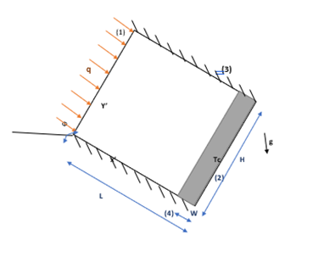

Fig. 1 Problem geometry and boundary conditions

The flow is assumed to be steady, laminar and two-dimensional. Here the dimension perpendicular to the page is considered to be much greater such that it does not impact the solution of the given considered geometry. From different studies it is known that this above assumption holds good when we the third dimension is much greater so that the flow and heat transfer are two-dimensional. The Rayleigh no, aspect ratio ,thermal conductivity of wall and fluid inclination impact the heat flow and motion of fluid this needs to be study. The boundary conditions can be written as follows,

At surface 1 q = constant

At surface 2 Tc = constant

At surface 3 and 4 u’= v’= 0;

# 3. MATHEMATICAL MODELING

## Assumption

* Fluid is non-absorbing ,perfect gas type fluid
* Steady flow
* Thermo physical properties are constant
* 3rd dimension is large, so not considered for solution
* Boussinesq Approximation, density is constant
* The boundary conditions are the no-slip conditions of all the rigid wall surfaces,
* Isothermal on the outer boundary of the solid wall
* Adiabatic on the other two sides perpendicular to the wall

## Boussinesq Approximation

Compressible Navier-stokes equation is highly non-linear and also mat add more complexity with the addition of extra density term if it varies with temperature so we if density varies with the temperature then the solution convergence may be doubtful as sometimes it do not converge and also requires high memory to store the data. Boussinesq approximation considers,

* Treat density as constant in the temporal and convection terms
* Assume that the only effect of density changes is in the gravitational terms( ρ.g )
* Low Mach no

By this approximation we reduce the non-linearity and memory required to store data as we are reducing the number of variables required to store per grid point. The other material properties (K, Cp, µ) still may vary with temperature, but in this project we have also kept the above thermo physical parameters to be constant meaning Prandtl number is constant throughout the study. The following non-dimensional variables are defined for simplification such that we can work more efficiently,

## Governing Equations

The non-dimensional form of the governing equations, the conservation of mass, momentum and energy, are,

Where is the general diffusion coefficient, which is equal to 1 in the fluid region and 1015 in the solid region, is equal to 1 in the fluid region and in the solid region. , are introduced to insure that in the solid region the conduction prevails and the motion is nearly zero also at the solid and liquid interface. The problem is governed by the non- dimensional parameters of Ra and Pr which are defined as follows,

The local Nusselt number is

The average Nusselt number is obtained by integrating the local Nusselt number along the wall

The normalized Nusselt number is calculated as

Where is for pure conduction for the same conditions. The stream function is calculated from its definition,

And by assuming at the boundaries. The streamlines are drawn by where n is a number of increment.

Finally equations boil down to

## Boundary Conditions

u=v=0 on all solid walls of enclosure

= -1 at x=0, 0<y<A

at x=1,0<y<A

at y=0 and A, 0x<1

Along the active side at

# 4. Numerical method

## Staggered Grid

Pressure Gradient term in the Navier-Stokes equation creates some intricacies while solving it. In some flow problems the pressure gradient exists and in some problem it does not exist and in discretization we evaluate values by interpolating the function and this interpolation creates the problem.

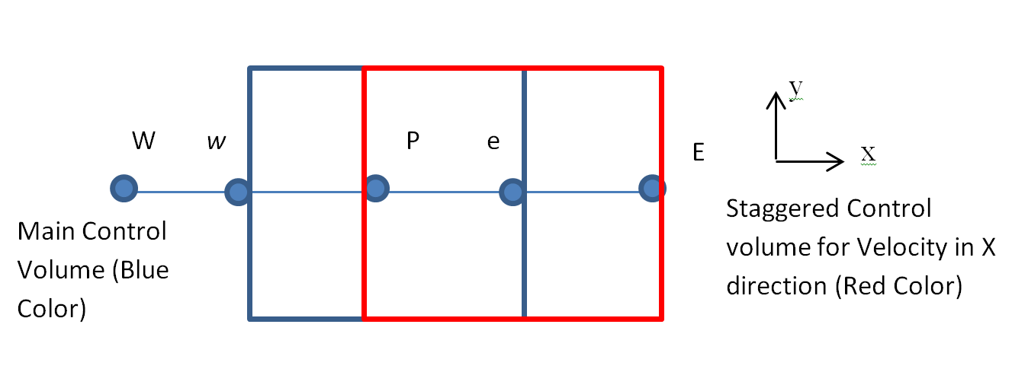

Fig. 2 Staggered and main Grid in X direction

At main grid points P, E pressure is defined which in turn is responsible for flow. In this method we create a different control volume which has its own existence and coordinates and hence new sets of calculation are needed to perform for it ,as in whole domain we have some grid points for velocity and other points for scalar or pressure calculation. While calculating the velocity which happens at the main interface of the main control volume. As we know the flow is driven by the pressure gradient at ‘P’ and ‘E’ and we can calculate the pressure at P To overcome this problem we basically use the method of staggered grid in which we evaluate a pressure at ‘e’ .Once we have pressure at ‘e’ we can calculate the velocity at ‘e’ without interpolation and this method in which we measure variables at different locations considering different sets of control volume is known as staggered grid method and this method is suitable for grid having same size throughout domain.

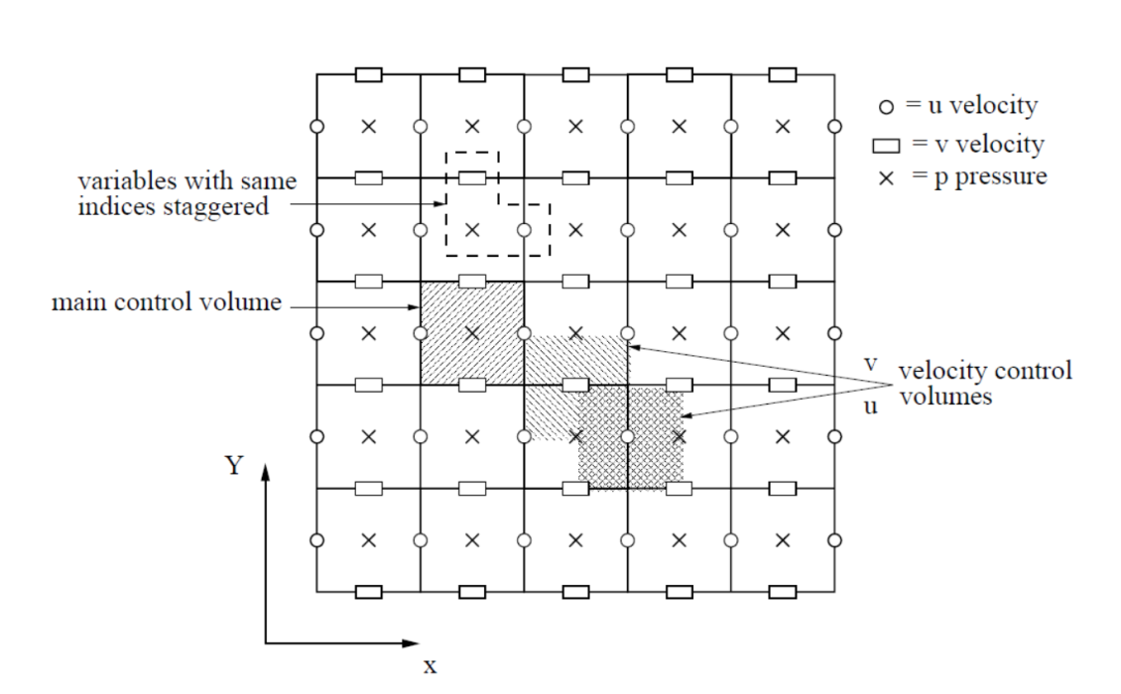

Fig. 3 Staggered Grid in 2 Dimensions

## SIMPLE (Semi Implicit Method for Pressure Linked Equations) Algorithm

Determining pressure field is perhaps the most meticulous task as there is dearth of a particular governing equation, determining the pressure values, for incompressible flow processes. A strategy to tackle this issue can be specifying the pressure field indirectly using the momentum equation, and then solving using an iterative strategy. To implement this finite volume discretization with staggered grid is considered. The iterative scheme used is known as SIMPLE algorithm.

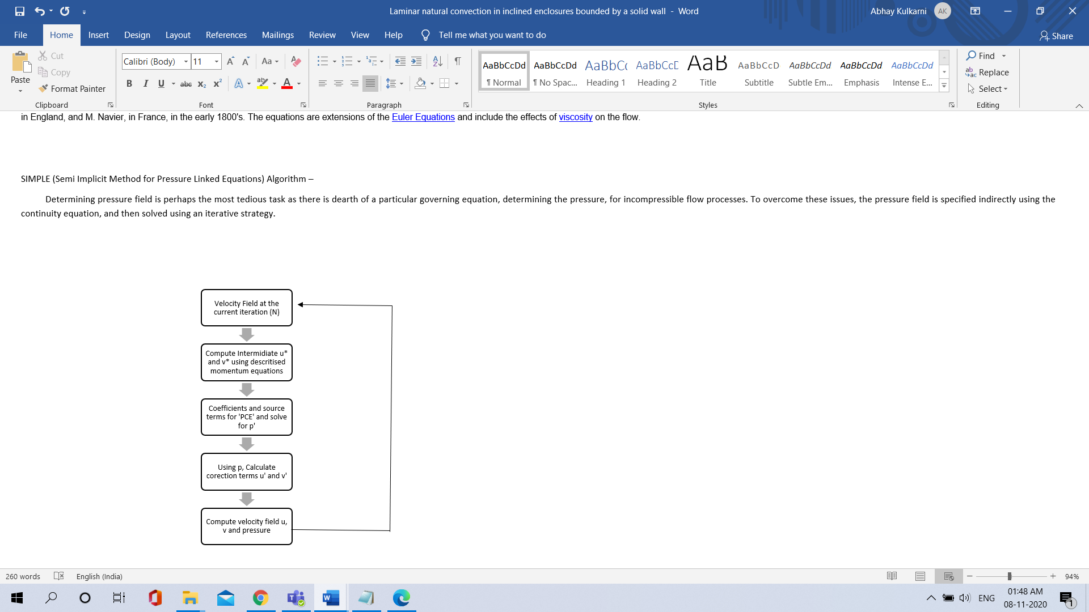

Fig. 4 Flowchart of SIMPLE algorithm

Features of Simple algorithm -

1. It is a semi implicit method. Velocity correction is function of pressure correction only and not on velocities of neighboring points.

For a forward staggered grid, 𝑢𝑖.𝑗 = 𝑢𝑒 and 𝑣𝑖.𝑗 = 𝑣n

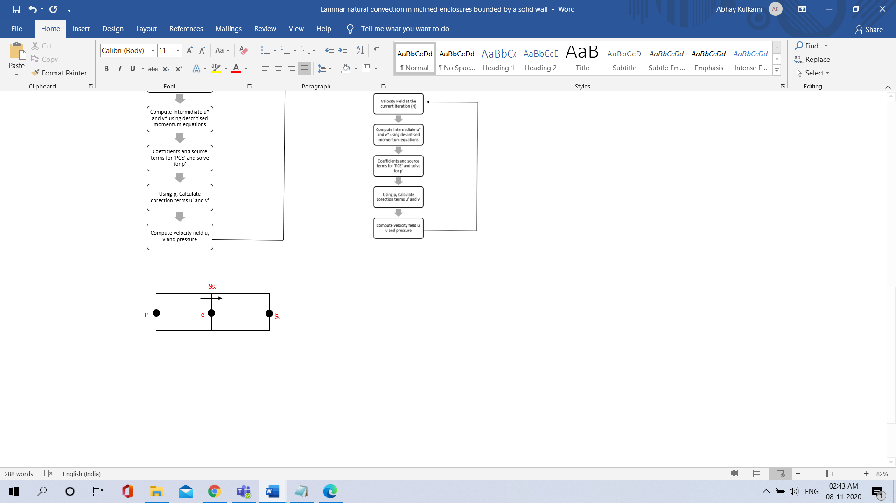

Fig. 5 Standard Grid Notations

the corrected variables are expressed as:

𝑢 = 𝑢∗ + 𝑢 ′

𝑣 = 𝑣∗ + 𝑣 ′

𝑝 = 𝑝∗ + p’

estimated velocities 𝑢 ∗ and 𝑣 ∗ are solved

the velocity corrections (𝑢 ′ 𝑣 ′) can be estimated by subtracting (3) from (1)

For the SIMPLE algorithm, the summation term on the RHS of Eq. (4) are neglected. Consequently, the velocity corrections can be expressed as

𝑢𝑒 ′ = 𝑑𝑒(𝑝𝑃 ′ − 𝑝𝐸 ′ )

𝑣𝑛 ′ = 𝑑𝑛(𝑝𝑃 ′ − 𝑝𝑁 ′ )

Where 𝑑𝑒 = ∆𝑦/𝑎𝑒 and 𝑑𝑛 = ∆𝑥/𝑎𝑛.

The pressure correction 𝑝 ′ is solved by discretizing the continuity equation as:

(𝑢𝑒 − 𝑢𝑤) ∆𝑦 + (𝑢𝑒 − 𝑢𝑤) ∆𝑥 = 0

By substitution of Eq. 5, Eq. 6 becomes:

Where

=∆𝑦, =w∆𝑦, =n∆𝑦, =s∆𝑦,

And

The source term 𝑏𝑝 is given as:

𝑏𝑝 = +

This simplification requires the application of under-relaxation such that Eq.2 becomes:

𝑝 = 𝑝∗ + p’

# 5. RESULTS AND DISCUSSION

## To study the effect of inclination

The effect of inclination was studied at various angle of inclination. The effect of the inclination angle is studied by varying phi from 30 to 180 degree for the case of Ra=10^6, W=0.2 ,kr = 10 and A = 1. Flow and temperature fields for A = 1 and phi= 30, 90, 120 are shown in Fig. 6 to 8. Starting from the case with small phi, streamlines are deformed in the direction of gravity and this is increasing with increasing phi. As the wall with constant heat flux becomes positioned at the top, the heat transfer becomes more dominated by conduction. Isotherms on the right-hand side clearly show this situation. Isotherms for phi= 120 degree, for example, show a dominant conduction regime.

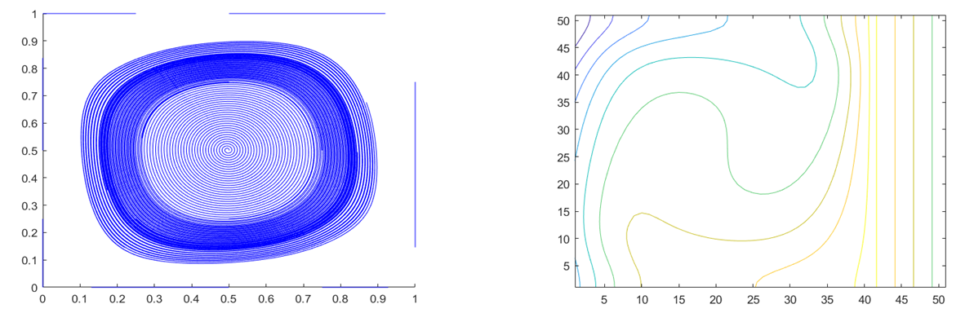

Fig. 6 Variation of Streamlines and Isotherm with 10^6 Rayleigh number and at 30-degree angle of inclination

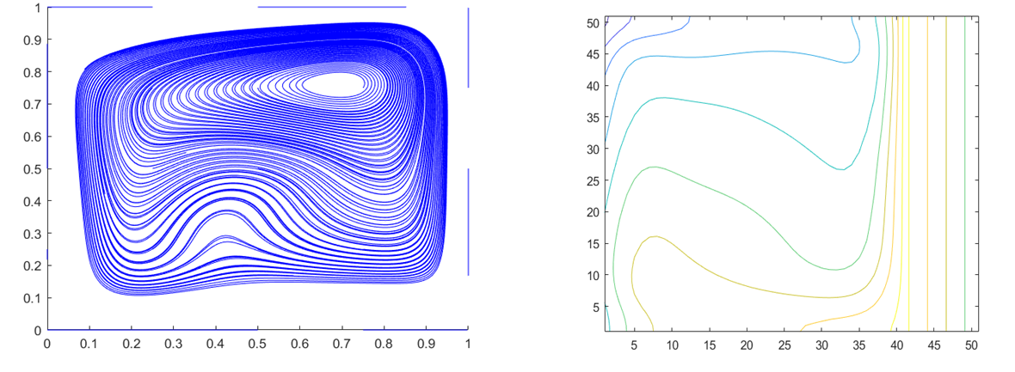

Fig. 7 Variation of Streamlines and Isotherm with 10^6 Rayleigh number and at 90-degree angle of inclination

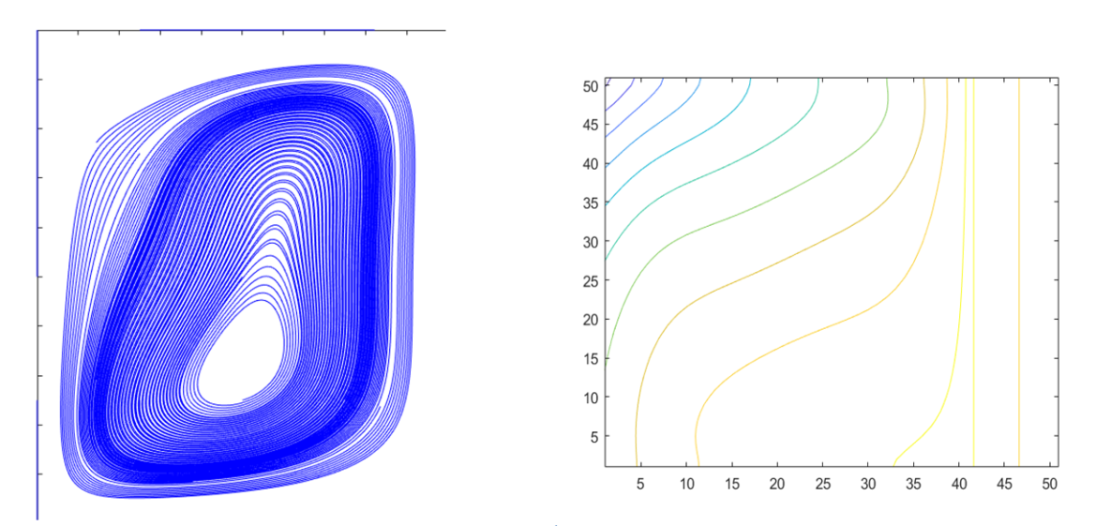

Fig. 8 Variation of Streamlines and Isotherms with 10^6 Rayleigh number and at 120-degree angle of inclination

## To study the effect of Rayleigh number

Streamline and isothermal line patterns are found to be similar for all the cases at low Rayleigh numbers whereas considerable differences are observed at high Rayleigh numbers. The temperature gradient within the solid wall is very small and the temperature at the internal surface is almost the same as the imposed uniform temperature at its outer boundary. For Ra = 10^3, the isotherms show a heat transfer by quasi conduction and the convection become dominant for increasing Ra number as seen in Fig. 10 and 11. For increasing Ra number, the isotherms show a stratified flow within the enclosure with steep gradients near the vertical boundaries. The streamlines in Fig. 9-11 show increasing convection with increasing Ra number. For Ra = 10^5, the streamlines are quasi-symmetric. They become skewed with increasing flow near the vertical boundaries.

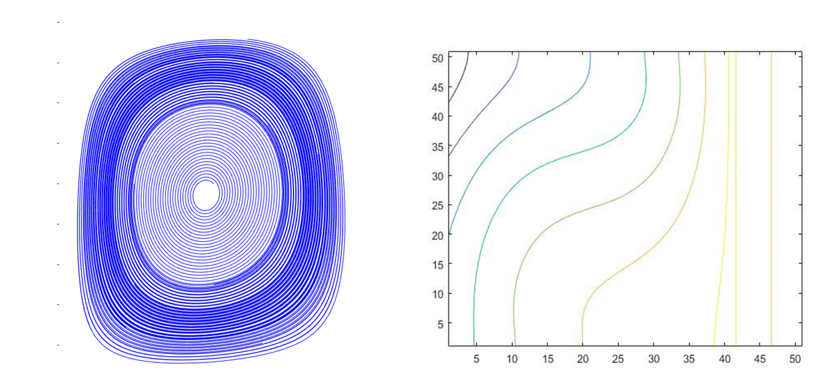

Fig. 9 Variation of Streamlines and Isotherms with 1000 Rayleigh number at 90 degree

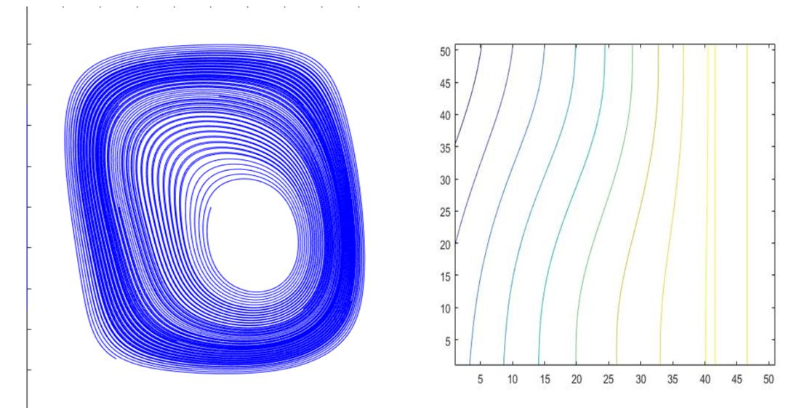

Fig. 10 Variation of Streamlines and Isotherms with 100000 Rayleigh number at 90 degree

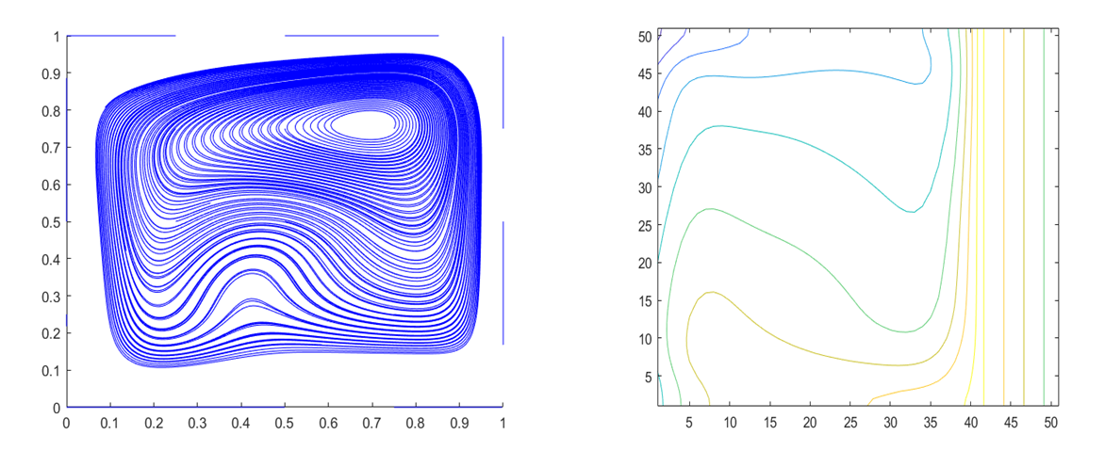

Fig. 11 Variation of Streamlines and Isotherms with 1000000 Rayleigh number at 90 degree

## To study the effect of conductivity

With increase in conductivity ratio the skewedness can be observed to increase. These results are expected since the temperature of the inner surface of the wall decreases with increasing kr ,as can be confirmed by examining the isotherms. The results show a large temperature gradient across the wall for kr = 1 in Fig. 12, that becomes negligibly small as kr increases as in Fig. 13. As a result, the convection increases since the temperature differential becomes larger with increasing kr .

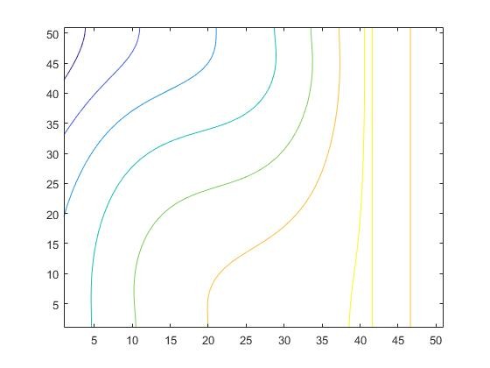

Fig. 12 Variation in isotherms with the conductivity ratio 1 at Ra=100000

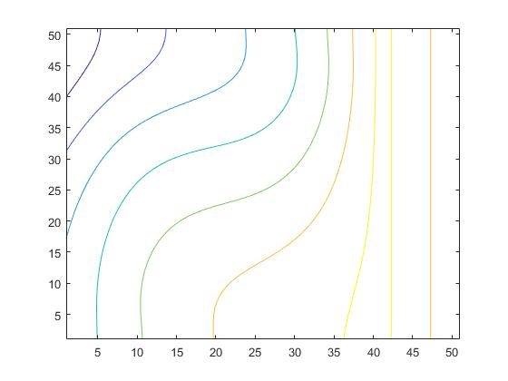

Fig. 13 Variation in the isotherms with conductivity ratio 10 at Ra=100000

# 6. MATLAB CODE

%% finding the temp. variation for the solid part

% given parameters

dx=0.02;dy=dx;

D=1.0;

nx=(D/dx)+1;

ny=(D/dy)+1;

mu=1.8e-5;cp=1005;

Tc=20;q=100;k=mu*cp/0.72;h=2;

iter=1000;

Tw=(q/h)+Tc;

T=zeros(nx,ny);

%boundary conditions for the solid part

T(nx,:)=Tw;

T(41,:)=T(42,:)+q*dx/k;

T(:,1)=T(:,2);

T(:,ny)=T(:,ny-1);

for n=1:iter

for i=41:nx-1

for j=2:ny-1

T(i,j)=0.25*(T(i-1,j)+T(i+1,j)+T(i,j-1)+T(i,j+1));

T(41,:)=T(42,:)+q*dx/k;

T(:,1)=T(:,2);

T(:,ny)=T(:,ny-1);

end

end

end

% normalizing the temp.

for i=41:nx

for j=1:ny

T(i,j)=(T(i,j)-Tc)*k/(D*q);

end

end

% finding the temp. at the cell midpoint(for further calculations in fluid

% part)

for j=2:ny

T(41,j)=(T(41,j)+T(41,j-1))/2;

end

%% finding the temp. variation of fluid part

nx=41; ny=51; D=1.0;

dx=(D)/(nx-1); dy=D/(ny-1); dt=0.00001; %Re=10000;

un=0.0; us=0.0; gamma=1.0; Pr=0.72; kr=1.0; Ra=100000;

maxit=20000; phi=30;

% '_tilda' denotes assumed value

% '_n' denotes corrected value

u_tilda=0.0*ones(nx,ny+1); u_n=0.0*ones(nx,ny+1);

v_tilda=zeros(nx+1,ny); v_n=zeros(nx+1,ny);

p_dash=0.0*ones(nx+1,ny+1); p_n=0.0*ones(nx+1,ny+1);

T_n_plus_1=0.0*ones(nx+1,ny+1); % Temp. at timestep n

T_n=0.0*ones(nx+1,ny+1); % temp. at timestep n+1

% values at normal grid point

u_cell=zeros(nx,ny); v_cell=zeros(nx,ny); p_cell=zeros(nx,ny); T_cell=zeros(nx,ny);

nx=41;

for t=0:maxit

%B.Cs of u velocity

for i=1:nx

u_n(i,1)=(2*us)-u_n(i,2);

u_n(i,ny+1)=(2*un)-u_n(i,ny);

end

for j=1:ny+1

u_n(1,j)=0.0;

u_n(nx,j)=0.0;

end

%B.Cs of v velocity

for j=1:ny

v_n(1,j)=-v_n(2,j);

v_n(nx+1,j)=-v_n(nx,j);

end

for i=1:nx+1

v_n(i,1)=0.0;

v_n(i,ny)=0.0;

end

%solving the temperature transport equation

for i=2:nx

for j=2:ny

axd=dx/dy; ayd=dy/dx;

aec=u_n(i,j)*dy;

awc=u_n(i-1,j)*dy;

anc=v_n(i,j)*dx;

asc=v_n(i,j-1)*dx;

%hybrid scheme

ae=max([-aec,axd-aec/2,0]);

aw=max([awc,axd+awc/2,0]);

an=max([-anc,axd-anc/2,0]);

as=max([asc,axd+asc/2,0]);

ap=ae+aw+an+as+(aec-awc+anc-asc);

T_n_plus_1(i,j)=T_n(i,j)...

-dt/dx/dy*(ap*T_n(i,j)-ae*T_n(i+1,j)-aw*T_n(i-1,j)-an*T_n(i,j+1)-as*T_n(i,j-1));

end

end

%B.Cs of temperature

for j=1:ny

T_n_plus_1(1,j)=(-1*dx)+T_n_plus_1(2,j);

T_n_plus_1(nx+1,j)=2*T(41,j)-T_n_plus_1(nx,j);

end

for i=1:nx+1

T_n_plus_1(i,1)=T_n_plus_1(i,2);

T_n_plus_1(i,ny+1)=T_n_plus_1(i,ny);

end

T_n=T_n_plus_1;

% solving for x momentum equation

for i=2:nx-1

for j=2:ny

axd=gamma*Pr*dy/dx; ayd=gamma*Pr*dx/dy;

aec=u_n(i+1,j)*dy;

awc=u_n(i-1,j)*dy;

anc=(v_n(i,j)+v_n(i+1,j))*0.5*dx;

asc=(v_n(i,j-1)+v_n(i+1,j-1))*0.5*dx;

%hybrid scheme

ae=max([-aec,axd-aec/2,0]);

aw=max([awc,axd+awc/2,0]);

an=max([-anc,axd-anc/2,0]);

as=max([asc,axd+asc/2,0]);

ap=ae+aw+an+as+(aec-awc+anc-asc);

u_tilda(i,j)=u_n(i,j)...

-(dt/dx)*(p_n(i+1,j)-p_n(i,j))...

-(dt/dx/dy)*(ap*u_n(i,j)-ae*u_n(i+1,j)-aw*u_n(i-1,j)-an*u_n(i,j+1)-as*u_n(i,j-1))...

+Ra*Pr*cosd(phi)*0.5*(T_n_plus_1(i+1,j)+T_n_plus_1(i,j))*dt;

end

end

for i=1:nx

u_tilda(i,1)=(2*us)-u_tilda(i,2);

u_tilda(i,ny+1)=(2*un)-u_tilda(i,ny);

end

for j=1:ny+1

u_tilda(1,j)=0.0;

u_tilda(nx,j)=0.0;

end

% solving for y momentum equation

for i=2:nx

for j=2:ny-1

axd=gamma*Pr*dy/dx; ayd=gamma*Pr*dx/dy;

aec=(u_n(i,j)+u_n(i,j+1))*0.5*dy;

awc=(u_n(i-1,j)+u_n(i-1,j+1))*0.5*dy;

anc=v_n(i,j+1)*dx;

asc=v_n(i,j-1)*dx;

%hybrid scheme

ae=max([-aec,axd-aec/2,0]);

aw=max([awc,axd+awc/2,0]);

an=max([-anc,axd-anc/2,0]);

as=max([asc,axd+asc/2,0]);

ap=ae+aw+an+as+(aec-awc+anc-asc);

v_tilda(i,j)=v_n(i,j)...

-(dt/dx)*(p_n(i,j+1)-p_n(i,j))...

-(dt/dx/dy)*(ap*v_n(i,j)-ae*v_n(i+1,j)-aw*v_n(i-1,j)-an*v_n(i,j+1)-as*v_n(i,j-1))...

+Ra*Pr*sind(phi)*0.5*(T_n_plus_1(i,j+1)+T_n_plus_1(i,j))*dt;

end

end

for j=1:ny

v_tilda(1,j)=-v_tilda(2,j);

v_tilda(nx+1,j)=-v_tilda(nx,j);

end

for i=1:nx+1

v_tilda(i,1)=0.0;

v_tilda(i,ny)=0.0;

end

% solving for pressure correction

p_dash=p_n; error=10.0; max1=0.0; iter=0;

while(error>0.0001)

for i=2:nx

for j=2:ny

p_dash(i,j)=(0.5/(dx^2+dy^2))*(((dy^2)*(p_dash(i+1,j)+p_dash(i-1,j)))...

+((dx^2)*(p_dash(i,j+1)+p_dash(i,j-1)))...

-((dx*dy/dt)*(((u_tilda(i,j)-u_tilda(i-1,j))*dy)...

+((v_tilda(i,j)-v_tilda(i,j-1))*dx))));

end

end

max1=0.0;

for i=2:nx

for j=2:ny

error=abs(p_dash(i,j)-p_n(i,j));

if (error>max1)

max1=error;

end

end

end

error=max1;

p_n=p_dash;

iter=iter+1;

end

% finding the corrected u

for i=2:nx-1

for j=2:ny

u_n(i,j)=u_tilda(i,j)-((dt/dx)*(p_dash(i+1,j)-p_dash(i,j)));

end

end

% finding the corrected v

for i=2:nx

for j=2:ny-1

v_n(i,j)=v_tilda(i,j)-((dt/dy)*(p_dash(i,j+1)-p_dash(i,j)));

end

end

end

% calculating the values at cell node points

for i=1:nx

for j=1:ny

u_cell(i,j)=(u_n(i,j+1)+u_n(i,j))/2;

v_cell(i,j)=(v_n(i+1,j)+v_n(i,j))/2;

p_cell(i,j)=(p_n(i,j)+p_n(i+1,j)+p_n(i+1,j+1)+p_n(i,j+1))/4;

T_cell(i,j)=(T_n_plus_1(i,j)+T_n_plus_1(i+1,j)+T_n_plus_1(i+1,j+1)+T_n_plus_1(i,j+1))/4;

end

end

% w=zeros(nx,ny);

% for i=2:nx-1

% for j=2:ny-1

% w(i,j)=(-(u_cell(i,j+1)-u_cell(i,j-1))/(2*dy))+((v_cell(i+1,j)-v_cell(i-1,j))/(2*dx));

% end

% end

% appending the covection obtained temp. values to the global temp. matrix

for i=1:41

for j=1:51

T(i,j)=T_cell(i,j);

end

end

T_trans=T';

for i=1:51

T1(i,:)= T_trans(52-i,:);

end

% plotting the stramlines and isotherms for the u,v and T values obtained.

[x,y]=meshgrid(linspace(0,1,5),linspace(0,1,5));

lines=streamline(stream2(linspace(0,1,nx),linspace(0,1,ny),u_cell',v_cell',x,y));

contour(T1)